

***GOVERNMENT POLYTECHNIC, RATNAGIRI***

**DEPARTMENT OF ELECTRONICS AND**

**TELECOMMUNICATION**

PROJECT REPORT ON

***DTMF BASED HOME AUTOMATION USING 89S51***

***MICROCONTROLLER***

SUBMITTED BY

**KALYANI KRISHNAKANT MULE -3420**

**MADHURITA DILIP KHARAT -3422**

**MADHURI SANTOSH LAD -3439**

**SAMIKSHA SUBHASH KOLAPATE -3442**

UNDER THE VALUABLE GUIDENCE OF,

**Mrs. S. V. NEMADE.**

**MAHARASHTRA STATE BOARD OF TECHNICAL**

**EDUCATION**

**IN THE ACADEMIC YEAR 2014-15**



**CERTIFICATE**

**THIS IS TO CERTIFY THAT,**

**KALYANI KRISHNAKANT MULE.**

**MADHURITA DILIP KHARAT.**

**MADHURI SANTOSH LAD.**

**SAMIKSHA SUBHASH KOLAPATE.**

**From final year Electronics and Telecommunication engineering have**

**completed their project on**

**DTMF BASED HOME AUTOMATION SYSTEM USING**

**89S51 MICROCONTROLLER**

**Mrs. NEMADE. DR.R.R.WAKODKAR MR.S.R.KELKAR**

**(PROJECT GUIDE) (H.O.D) (PRINCIPLE)**

***ACKNOWLEDGEMENT***

“A GOOD TEACHER TEACHES,

# BUT A TRULY

MEMORABLE TEACHER INSPIRES”

The completion of project work is a milestone in an engineering student’s life but without proper guidance and advice they are left nowhere. So we would like to take this opportunity to thank our **Head Of Department Dr. R. R. Wakodkar** sir for kind support and maintaining a high level of disciplinary environment in our college.

We would like to express our regards and gratitude to our project guide **Mrs. S. V. NEMADE** for encouraging us to do this project.

We are highly obliged to Mrs. Nemade, lecturer of Electronics and our project guide, for her extra efforts to this project came from an idea to real practice. She also helped to achieve great success in minimum possible time and her patience, cooperation and bearing all responsibilities during this project.

We would also like to thank our college faculty for allowing us to go ahead with this project us with lab facilities. Last but not the least ; we would like to thank our classmates for encouraging us to bring this project in its present form.

# *INDEX*

|  |  |  |
| --- | --- | --- |
| SR NO. | CONTENT | PAGE NO. |
| 1. | INTRODUCTION | 5 |
| 2. | WHAT IS HOME AUTOMATION? | 7 |
| 3. | WHAT IS DTMF? | 8 |
| 4. | BLOCK DIAGRAM OF DTMF SYSTEM | 10 |
| 5. | HOW IT ISWORKS? | 12 |
| 6. | HARDWARE DESCRIPTION: | 12-29 |
| 7. | CIRCUIT DIAGRAM | 14 |
| 7. | COMPOENTS LIST | 15 |
| 8. | FEATURES OF TONE DECODING(DTMF) | 17 |
| 9. | PIN DIAGRAM | 18 |
| 10. | PIN DISCRIPTION | 19 |
| 11. | DTMF DECODER 8870 | 22 |
| 12. | POWER SUPPLY | 24 |
| 13. | LCD INTERFACING | 29 |
| 14. | RELAY DRIVER CIRCUIT | 29 |
| 15. | SOFTWARE DISCRIPTION: | 31-42 |
| 16. | PCB LAYOUTS | 31 |
| 17. | PROGRAMS | 34 |
| 18. | ADVANTAGES AND DISADVANTAGES | 43 |
| 19. | REFERENCE | 44 |
| 20. | CONCLUSION | 45 |
| 21. | COSTING | 46 |

**INTRODUCTION**

The aim of the proposed system is to develop a cost effective solution that will provide controlling of home appliances remotely and enable home security against instruction in the absence of homeowner. The system provides availability due to development of a low cost system. The home appliances control system with an affordable cost was thought to be built that should be mobile providing remote access to the appliances and allowing home security. Though devices connected as home and office appliances consume electrical power. These devices should be controlled as well as turn on/off if required. Most of the times it is done manually. Now it is a necessity to control devices more effectively and efficiently at anytime from anywhere.

In this system, we are going to develop a cellular phone based home/office appliance. This system is designed for controlling arbitrary devices, it includes a cell phone (not included with the system kit, end user has to connect his/her cell phone to the system) which is connect to the system via head set. To active the cellular phone unit on the system a call is to be made and as the call is answered, in response the user would enter a two/three digit password to access the system to control devices.

As the caller press the specific password, it results in turning ON or OFF specific device. The device switching is achieved by Relays. Security preserved because these dedicated passwords . The device switching is achieved by Relays. Security preserved because these dedicated passwords owned and known by selected persons only. For instance, our system content mechanism, which is capable of informing up to five different numbers over telephony network about the nature of the event. The underlying principle mainly relies up on the ability of DTMF (Double Tune Multi Frequency) ICs to generate DTMF corresponding to a number or code in the number pad and to detect the same number or code from its corresponding DTMF. In detail, a DTMF generator generates two frequencies corresponding to a number or code in the number pad which will be transmitted through the communication networks constituting the transmitter section which is simply equivalent to a mobile set. In the receiver part, the DTMF detector IC, for example IC MT 8870 detects the number or code represented by DTMF back, through the inspection of the two transmitted.

This project based on DTMF ([Dual Tone multi frequency](http://www.engineersgarage.com/tutorials/dtmf-dual-tone-multiple-frequency)) which is generated in cellular phones. Here, by using a cell phone we controls the home appliances from anywhere in the world (In Network Area). Below you can see the diagram of DTMF keypad. When we press any key then it generates a frequency after mixing two frequencies. And then send it to the receiver end over communication channel.

#### ****What is Home Automation?****

We all love to live a luxurious life where everything is perfect and the way we want it to be. We know how far technology has reached today and it is coming up with new inventions now and then. Talking about home automation, you must have heard about building automation where the many works of the building like operating lifts, lights, generators, yard watering, pet feeding and many more is done automatically. If you wondering as to how that is possible then it is, with the help of a computer network. In home automation people need not do works like switching on fans, light and other devices manually. It is done by a computer network which is connected to these devices. This helps to remotely access devices with the help of the internet.  The sole advantage of getting your home is not luxury alone. It does include other factors like convenient living, saving energy and safety benefits i.e. home security .In easier terms, home automation is a home that is controlled by computer and IT.

* **What is DTMF?**

**DTMF** is a signalling system for identifying the keys or better say the number dialed on a **pushbutton or DTMF keypad**. The early telephone systems used pulse dialing or loop disconnects signalling. This was replaced by multi frequency (MF) dialing. DTMF is a multi frequency tone dialing system used by the push button keypads in telephone and mobile sets to convey the number or key dialed by the caller. DTMF has enabled the long distance signalling of dialed numbers in voice frequency range over telephone lines. This has eliminated the need of telecom operator between the caller and the call and evolved automated dialing in the telephone switching centers. **DTMF** (**Dual tone multi frequency**) as the name suggests uses a **combination of two sine wave tones** to represent a key. These tones are called row and column frequencies as they correspond to the layout of a telephone keypad. 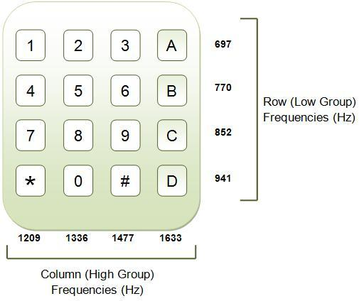

A **DTMF keypad** (generator or encoder) generates a sinusoidal tone which is **mixture of the row and column frequencies**. The row frequencies are low group frequencies. The column frequencies belong to high group frequencies. This prevents misinterpretation of the harmonics. Also the frequencies for ***DTMF*** are so chosen that none have a harmonic relationship with the others and that mixing the frequencies would not produce sum or product frequencies that could mimic another valid tone. The high-group frequencies (the column tones) are slightly louder than the low-group to compensate for the high-frequency roll off of voice audio systems.

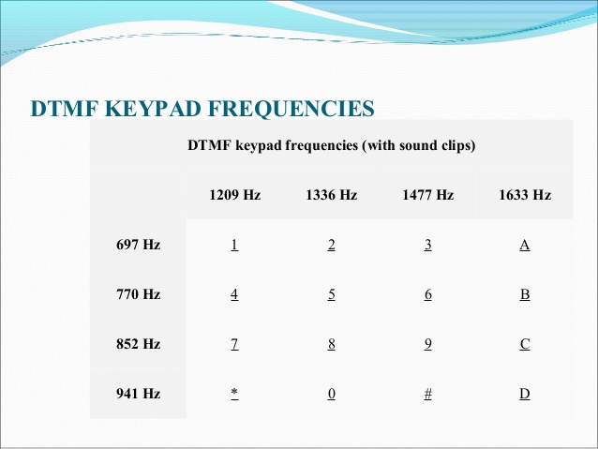

* **Block diagram of DTMF system -**

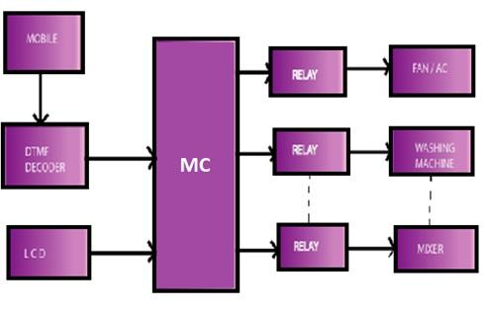

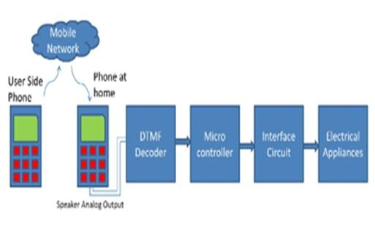

This system is designed for controlling the devices; it includes a cell phone which is connecting to the system via head set. To active the cellular phone part of the system a call is to be made and as the call is answered, in response the user would enter a three/four(as he/she want) digit password to access the system to control devices. As the caller press the specific password, it results in turning ON or OFF specific device. The device switching is achieved by Relays.

* **How it is works?**

In DTMF based home automation system DTMF technology is used. In this project there are in all three main circuits used.

1. Basic circuit using microcontroller.

2. DTMF Decoder

3. Relay section

Here ,LCD display is also interface. In this microcontroller only two ports are used

Port 1 acts as an input port and

Port 2 acts as an output port

Here serial communication section is also used using RS232and MAX 232.

Firstly we will start with each of the section i.e. main circuit

The main circuits is basic circuits which can be used for any application. It consist of microcontroller, power supply circuits,

RS232, MAX232 and LCD display. The decoder consist of 8870 decoder and 7808 IC and connector. The relay circuit which consist of four relay switches and connectors to which our appliances are connector.

The adapter convert 230v ac into 12v dc supply which is given to power supply circuit which converts 12v dc into 5v dc using IC7805 bridge rectifier ,capacitor filter .This 5v dc supply is given to microcontroller LCD,DTMF Decoder and relay circuitry.

The cell phone is connected to DTMF decoder which is placed near our circuit .This circuit is placed at home. When user calls to this cello phone then call is automatically received by this cell phone. When user pressed any key then the decoder get the particular frequency from the cell phone and converts it into appropriate code which is given to inverter. The inverted output is given to port 1 of microcontroller which then compares this specific code with the code which is burned into microcontroller. If any of the condition is true the microcontroller gives the output to port 2 which is acts as a output port output which is directly connected to the relay section to which home appliances are connected and hence the the appliances are controlled depending on the relay position.

**HARDWARE DISCRIPTION**

**Circuit Diagram:**

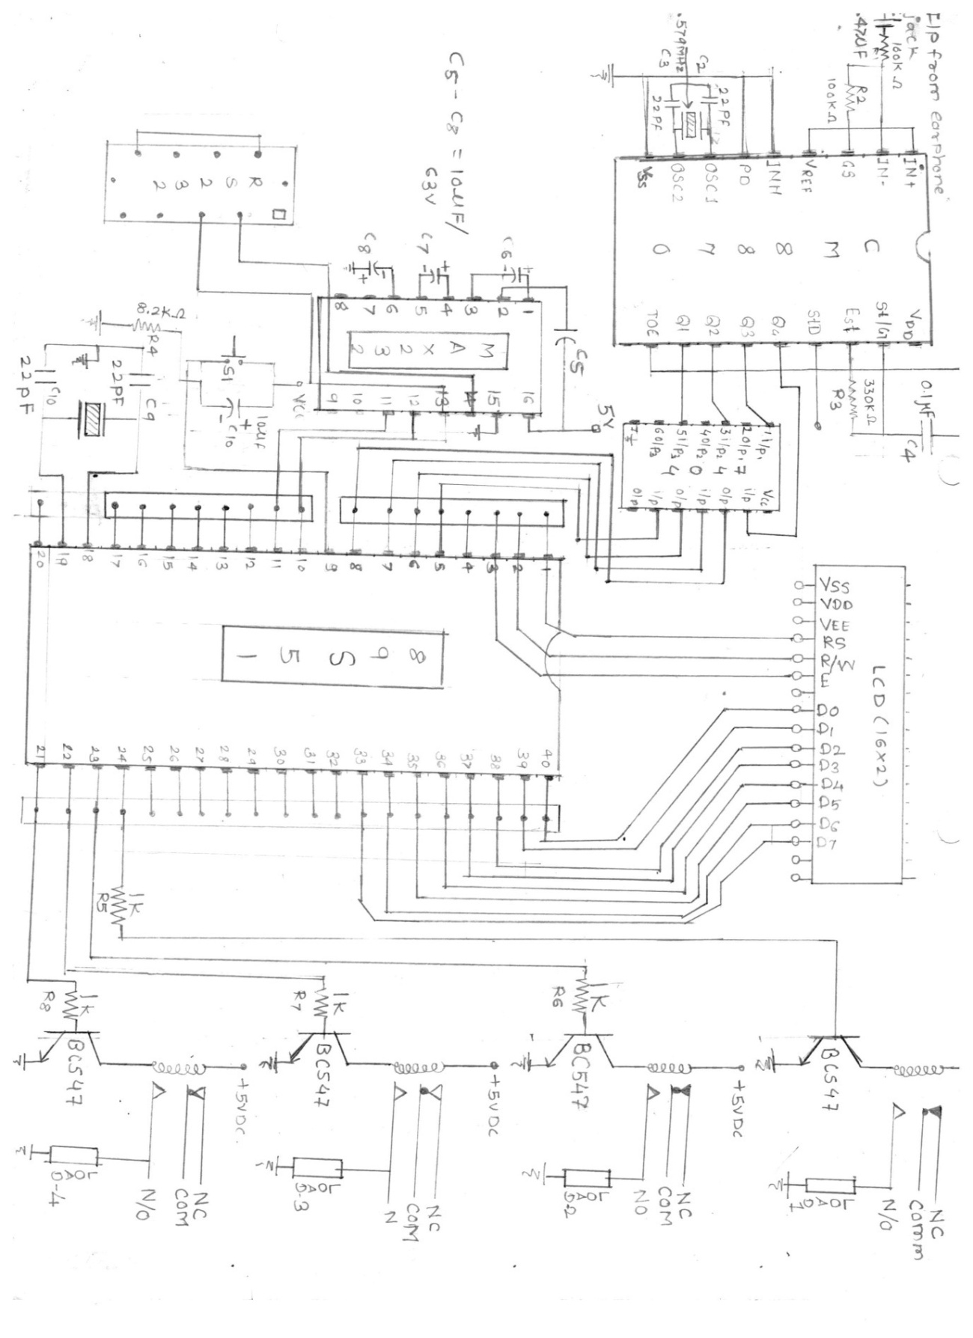

**COMPONENTS LIST:**

1. *DTMF DECODER SECTION:*

* *R1,R2:* 100K [Brown, Black, Yellow, Gold]
* R3: 330k[Orange, Orange, yellow, gold]
* R5,R6,R7,R8:10K[Brown, Black, Orange, Gold]
* C1: 0.47uf/50v Electrolytic
* C2,C3: 22pf[Mica]
* 1 nos: 18 PIN IC SOCKET
* 1 nos: 14 PIN IC SOCKET
* U1: CM8870P1
* U2: 74AC04
* Y1: 3.579545 MHZ Crystal

2. Basic circuit using microcontroller section:

* R3: 1k[brown, Black, Red, Gold]
* R4: 8.2k[Gray, Red, Red, Gold]
* R3: 560[Green, Blue, Brown, Gold]
* C1: 470uf/63v Electrolytic
* C2,C3,C4,C5,C6,C7: 10uf/63V Electrolytic 6
* C8,C9: 22pf mica
* Y1: 11.0592MHZ Crystal
* 9 PIN Connector: RS232
* 1 nos: 40 PIN IC SOCKET
* 1 nos: 16 PIN IC SOCKET
* 1 nos: 16 PIN LCD SOCKET
* U4: 16x2 LCD MODULES
* U1: MAX 232
* U2: AT 89S51
* U3: LM 7805( 3 pin voltage regulator)
* D1,D2,D3,D4: IN 4007 MIC
* D5: LED
* 7 JUMPERS

1. **RELAY SECTION**:

* R1-R8: 1K[Brown, Black, Red, gold]
* Q1,Q2,Q3,Q4: BC547
* D1,D2,D3,D4: 4 LED
* D5-D8: IN 4007MIC
* RL1-RL4: 12V SPDT RELAY
* **FEATURES OF TONE DECODING(DTMF):**

1. High compatibility with all cell phone models.

3. Inefficient, time consuming.

4. Additional hardware required(convert sound to binary)

AT89C51 is an 8-bit [microcontroller](http://www.engineersgarage.com/microcontroller) and belongs to Atmel's [8051 family](http://www.engineersgarage.com/8051-microcontroller). **ATMEL 89C51** has 4KB of Flash programmable and erasable read only memory (PEROM) and 128 bytes of RAM. It can be erased and program to a maximum of 1000 times .In 40 pin AT89C51, there are four ports designated as P1, P2, P3 and P0. All these ports

are 8-bit bi-directional ports, *i.e.*, they can be used as both input and output ports. Except P0 which needs external pull-ups, rest of the ports have internal pull-ups. When 1s are written to these port pins, they are pulled high by the internal pull-ups and can be used as inputs. These ports are also bit addressable and so their bits can also be accessed individually.

Port P0 and P2 are also used to provide low byte and high byte addresses, respectively, when connected to an external memory. Port 3 has multiplexed pins for special functions like [serial communication](http://www.engineersgarage.com/microcontroller/8051projects/interface-serialport-RS232-AT89C51), hardware interrupts, timer inputs and read/write operation from external memory. AT89C51 has an inbuilt UART for serial communication. It can be programmed to operate at different baud rates. Including two [timers](http://www.engineersgarage.com/tutorials/timers-8051-timer-programming-tutorial) & hardware [interrupts](http://www.engineersgarage.com/tutorials/interrupts-8051-interrupt-programming), it has a total of six interrupts.

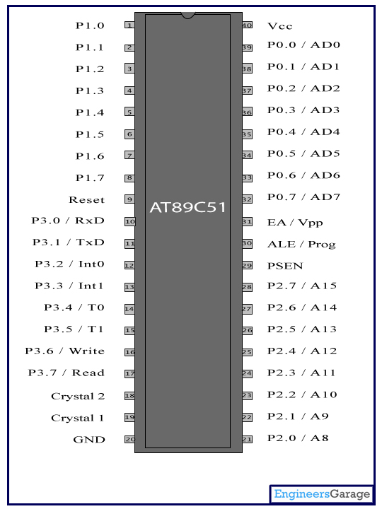**PIN DIAGRAM:**

|  |  |  |  |  |
| --- | --- | --- | --- | --- |
| **Pin No** | **Function** | | | **Name** |
| 1 | 8 bit input/output port (P1) pins | | | P1.0 |
| 2 | P1.1 |
| 3 | P1.2 |
| 4 | P1.3 |
| 5 | P1.4 |
| 6 | P1.5 |
| 7 | P1.6 |
| 8 | P1.7 |
| 9 | Reset pin; Active high | | | Reset |
| 10 | Input (receiver) for serial communication | RxD | 8 bit input/output port (P3) pins | P3.0 |
| 11 | Output (transmitter) for serial communication | TxD | P3.1 |
| 12 | External interrupt 1 | Int0 | P3.2 |
| 13 | External interrupt 2 | Int1 | P3.3 |
| 14 | Timer1 external input | T0 | P3.4 |
| 15 | Timer2 external input | T1 | P3.5 |
| 16 | Write to external data memory | Write | P3.6 |
| 17 | Read from external data memory | Read | P3.7 |
| 18 | Quartz crystal oscillator (up to 24 MHz) | | | Crystal 2 |
| 19 | Crystal 1 |
| 20 | Ground (0V) | | | Ground |
| 21 | 8 bit input/output port (P2) pins  /  High-order address bits when interfacing with external memory | | | P2.0/ A8 |
| 22 | P2.1/ A9 |
| 23 | P2.2/ A10 |
| 24 | P2.3/ A11 |
| 25 | P2.4/ A12 |
| 26 | P2.5/ A13 |
| 27 | P2.6/ A14 |
| 28 | P2.7/ A15 |
| 29 | Program store enable; Read from external program memory | | | PSEN |
| 30 | Address Latch Enable | | | ALE |
| Program pulse input during Flash programming | | | Prog |
| 31 | External Access Enable;  Vcc for internal program executions | | | EA |
| Programming enable voltage; 12V (during Flash programming) | | | Vpp |
| 32 | 8 bit input/output port (P0) pins    Low-order address bits when interfacing with external memory | | | P0.7/ AD7 |
| 33 | P0.6/ AD6 |
| 34 | P0.5/ AD5 |
| 35 | P0.4/ AD4 |
| 36 | P0.3/ AD3 |
| 37 | P0.2/ AD2 |
| 38 | P0.1/ AD1 |
| 39 | P0.0/ AD0 |
| 40 | Supply voltage; 5V (up to 6.6V) | | | Vcc |

* **Features of 8951:**

* Compatible with MCS-51 Products
* 4 Kbytes of In-System Reprogrammable Flash Memory. Endurance   1,000 Write/Erase Cycles
* Fully Static Operation: 0 Hz to 24 MHz
* Three-Level Program Memory Lock.
* 128 x 8-Bit Internal RAM
* 32 Programmable I/O Lines
* Two 16-Bit Timer/Counters
* Six Interrupt Sources
* **DTMF DECODER 8870**

*Features:*

• Complete DTMF Receiver

• Low power consumption

• Internal gain setting amplifier

• Adjustable guard time

• Central office quality

• Power-down mode

• Inhibit mode

• Backward compatible

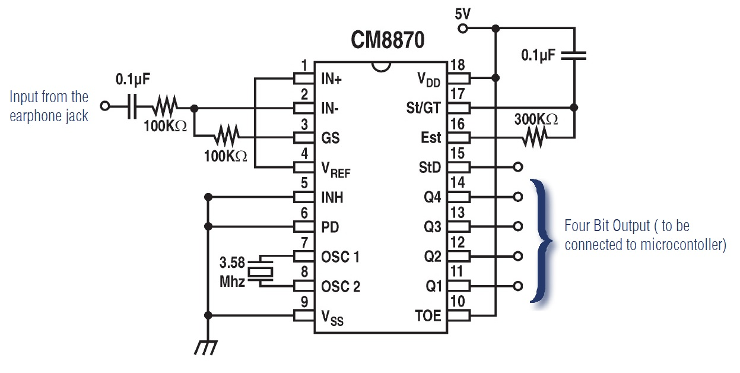

**Description:**

The MT8870D/MT8870D-1 is a complete DTMF Receiver integrating both the band split filter and digital decoder functions. The filter section uses

switched capacitor techniques for high and low group filters; the decoder uses digital counting techniques to detect and decode all 16 DTMF tone pairs into a 4-bit code. External component count is minimized by on chip provision of a differential input amplifier, clock oscillator and latched three-state bus

interface.

* **POWER SUPPLY:**

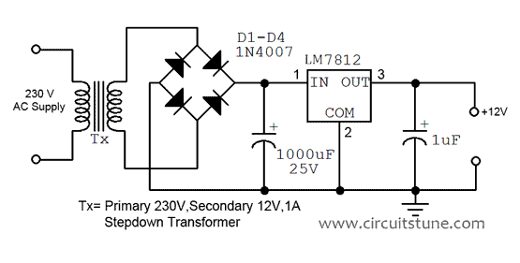

Power supply is a reference to a source of electrical power. A device or system that supplies electrical or other types of energy to an output load or group of loads is called a power supply unit or PSU. The term is most commonly applied to electrical energy supplies, less often to mechanical ones, & rarely to others. Here in our application we need a 5v DC power supply for all electronics involved in the project. This requires step down transformer, rectifier, voltage regulator, & filter circuit for generation of 5v DC power. Here a brief description of all the components is given as follows:

**TRANSFORMER: Transformer** is a device that transfers electrical energy from one circuit to another through inductively coupled conductors — the transformer's coils or "windings". single iron-rich core, or around separate but magnetically-coupled cores. A varying current in the first or "primary" winding creates a varying magnetic field in the core (or cores) of the transformer. This varying magnetic field induces a varying electromotive force (EMF) or "voltage" in the "secondary" winding. This effect is called mutual induction. If a load is connected to the secondary circuit, electric charge will flow in the secondary winding of the transformer and transfer energy from the primary circuit to the load connected in the secondary circuit. The secondary induced voltage *VS*, of an ideal transformer, is scaled from the primary *VP* by a factor equal to the ratio of the number of turns of wire in their respective windings:



**BRIDGE RECTIFIER**

A bridge rectifier makes use of four diodes in a bridge arrangement to achieve full-wave rectification. This is a widely used configuration, both with individual diodes wired as shown and with single component bridges where the diode bridge is wired internally.

**REGULATOR IC (78XX)** It is a three pin IC used as a voltage regulator. It converts unregulated DC current into regulated DC current. Normally we get fixed output by connecting the voltage regulator at the output of the filtered DC (see in above diagram). It can also be used in circuits to get a low DC voltage from a high DC voltage (for example we use 7805 to get 5V from 12V). There are two types of voltage regulators 1. Fixed voltage regulators (78xx, 79xx) 2. Variable voltage regulators (LM317) in fixed voltage regulators there is another classification 1. +ve voltage regulators 2. -ve voltage regulators.



Positive voltage regulators:

This includes 78xx voltage regulators. The most commonly used ones are 7805 and 7812. 7805 gives fixed 5V DC if input voltage is in (7.5V,20V).

**The Capacitor Filter:**

The simple capacitor filter is the most basic type of power supply filter. The application of the simple capacitor filter is very limited. It is sometimes used on extremely high-voltage, low-current power supplies for cathode-ray and similar electron tubes, which require very little load current from the supply. The capacitor filter is also used where the power-supply ripple frequency is not critical; this frequency can be relatively high. The capacitor (C1) shown in figure 4-15 is a simple filter connected across the output of the rectifier in parallel with the load.



**LCD INTERFACING:**

A 16x2 line LCD module to display the status of microcontroller and send the data signals through pin 32 to 39 and control signals port P1.0, P1.1, P1.2. Pin no.3 of the LCD is used to control the contrast by using preset VR1.

* **RELAY DRIVER CIRCUIT:**

The PCB contains 8 identical switched relay positions, power input and data positions via 9 pin SIP connector. A single pole double throw (SPDT) relay is connected to pin 21 to 24(P2.0 toP2.3) of the microcontroller through driver BC547. The relay requires 12v at a current of around 50mA which cannot provide by microcontroller. So the driver IC or transistor is added. The relay is used to operate the external electrical device. Normally the relay remains off. As soon as pin of the microcontroller goes high, the relay operates. The connected LED will glow to show that this relay is on. When the relay is switched on, it is cut off and signals are directly provided to the connected device through AC power supply.

**SOFTWARE DISCRIPTION**

* **PCB Layouts:**

*BASIC CIRCUIT USING 89C51 MICROCONTROLLER*

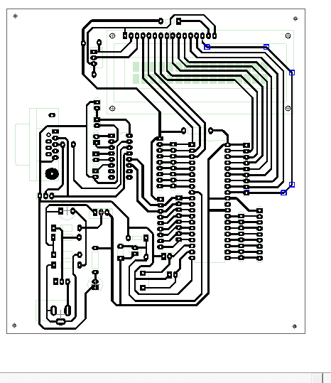

* DTMF DECODER:

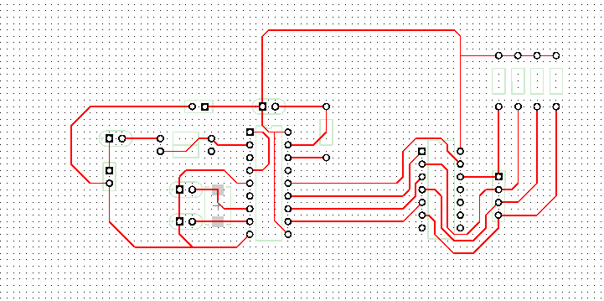

* RELAY SECTION:

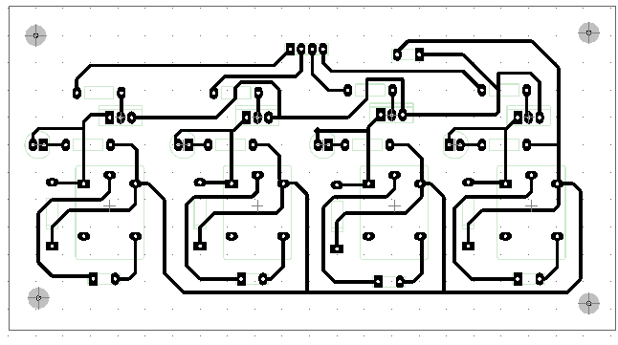

The **Project Windows** area is that part of the screen in which, by default, the Project Window, Functions Window, Books Window, and Registers Window are displayed.

Within the **Editor Windows** area, you are able to change the source code, view performance and analysis information, and check the disassembly code.

The **Output Windows** area provides information related to debugging, memory, symbols, call stack, local variables, commands, browse information, and find in files results.

If, for any reason, you do not see a particular window and have tried displaying/hiding it several times, please invoke the default layout of μVision through the **Window – Reset Current Layout** Menu**.**

**Positioning Windows**

The μ-Vision windows may be placed onto any area of the screen, even outside of the μ-Vision frame, or to another physical screen.

Click and hold the **Title Bar1** of a window with the left mouse button

Drag the window to the preferred area, or onto the preferred control, and release the mouse button

Please note, source code files cannot be moved outside of the **Editor Windows**2.\ Invoke the **Context Menu** of the window’s **Title Bar** to change the docking attribute of a window object. In some cases, you must perform this action before you can drag and drop the window.

vision displays docking helper controls3, emphasizing the area where the window will be attached. The new docking area is represented by the section highlighted in blue. Snap the window to the Multiple Document Interface (MDI) or to a Windows area by moving the mouse over the preferred control.

**μVISION**:

The μ Vision IDE is, for most developers, the easiest way to create embedded system programs. This chapter describes commonly used μ Vision features and explains how to use them.

A Context Menu, invoked through the right mouse button, is provided for most objects. You can use keyboard shortcuts and define your own shortcuts. You can use the abundant features of a modern editor. Menu items and Toolbar buttons are greyed out when not available in the Current context.

Graphical symbols are used to resemble options, to mark unsaved changes, or reveal objects not included into the project. Status Bars display context-driven information. You can associate μ-Vision to third-party tools.

* **Program:**

MICROCONTROLLER PROGRAMMING:

* + - * P0=CONNCTED DISPLAY DATALINE
      * P1.0=RS,P1.1=R/W,P1.2=E
      * P1.4-P1.7=INPUT FROM DTMF
      * P2.0-P2.3 OUTPUT

ORG 0000H

MOV P0, #00H

MOV P1, #0F0H

MOV P2, #00H

MOV DPTR, #MYCOM_7

C7: CLR A

MOVC A,@A+DPTR

ACALL CMNDWRT

ACALL DELAY

JZ SEND_DAT_7

INC DPTR

SJMP C7

SEND_DAT_7: MOV DPTR, #MYDATA_7

D7: CLR A

MOVC A,@A+DPTR

ACALL DATAWRT

ACALL DELAY

INC DPTR

JZ AGAIN_7

SJMP D7

AGAIN_7: SJMP MAIN

MYCOM_7: DB 38H, 0EH, 01H, 06,80H,0H

MYDATA_7: DB " WEL-COME ",0

MAIN: MOV A,P1

ANL A,#0F0H

CJNE A,#0E0H,NEXT

SETB P2.0

CLR P2.1

CLR P2.2

CLR P2.3

MOV DPTR, #MYCOM

C1: CLR A

MOVC A,@A+DPTR

ACALL CMNDWRT

ACALL DELAY

JZ SEND_DAT

INC DPTR

SJMP C1

SEND_DAT: MOV DPTR, #MYDATA

D1: CLR A

MOVC A, @A+DPTR

ACALL DATAWRT

ACALL DELAY

INC DPTR

JZ AGAIN

SJMP D1

AGAIN: SJMP NEXT

;;;;;;;;;;;;;;;;;;;;;;;;;;;;;;;;;;;;;;;;;;;;;;;;;;;;; 1

MYCOM: DB 38H,0EH,01H,06,80H,0

DATA: DB " DEVICE NO-1=ON ",0

NEXT: MOV A, P1

ANL A, #0F0H

CJNE A, #0D0H,NEXT_1

SETB P2.1

CLR P2.0

CLR P2.2

CLR P2.3

MOV DPTR,#MYCOM_2

C2: CLR A

MOVC A,@A+DPTR

ACALL CMNDWRT

ACALL DELAY

JZ SEND_DAT_2

INC DPTR

SJMP C2

SEND_DAT_2: MOV DPTR,#MYDATA_2

D2: CLR A

MOVC A,@A+DPTR

ACALL DATAWRT

ACALL DELAY

INC DPTR

JZ AGAIN_2

SJMP D2

AGAIN_2: SJMP NEXT_1

MYCOM_2: DB 38H,0EH,01H,06,80H,0

MYDATA_2: DB " DEVICE NO-2=ON ",0

;;;;;;;;;;;;;;;;;;;;;;;;;;;;;;;;;;;;;;;;;;;;;;;;;;;;;;

NEXT_1: MOV A, P1

ANL A,#0F0H

CJNE A,#0C0H,NEXT_2

SETB P2.2

CLR P2.0

CLR P2.1

CLR P2.3

MOV DPTR,#MYCOM_3

C3: CLR A

MOVC A,@A+DPTR

ACALL CMNDWRT

ACALL DELAY

JZ SEND_DAT_3

INC DPTR

SJMP C3

SEND_DAT_3: MOV DPTR,#MYDATA_3

D3: CLR A

MOVC A,@A+DPTR

ACALL DATAWRT

ACALL DELAY

INC DPTR

JZ AGAIN_3

SJMP D3

AGAIN_3: SJMP NEXT_2

;;;;;;;;;;;;;;;;;;;;;;;;;;;;;;;;;;;;;;;;;;;;;;;;;;;;;;;;;;;;;;;;;;;;;;;;;;;;;;;;;;;;;;;;; 3

MYCOM_3: DB 38H,0EH,01H,06,80H,0

MYDATA_3: DB " DEVICE NO-3=ON ",0

NEXT_2: MOV A, P1

ANL A, #0F0H

CJNE A, #0B0H,NEXT_3

SETB P2.3

CLR P2.0

CLR P2.1

CLR P2.2

MOV DPTR,#MYCOM_4

C4: CLR A

MOVC A,@A+DPTR

ACALL CMNDWRT

ACALL DELAY

JZ SEND_DAT_4

INC DPTR

SJMP C4

SEND_DAT_4: MOV DPTR,#MYDATA_4

D4: CLR A

MOVC A,@A+DPTR

ACALL DATAWRT

ACALL DELAY

INC DPTR

JZ AGAIN_4

SJMP D4

AGAIN_4: SJMP NEXT_3

MYCOM_4: DB 38H, 0EH, 01H, 06, 80H, 0

MYDATA_4: DB " DEVICE NO-4=ON ", 0

;;;;;;;;;;;;;;;;;;;;;;;;;;;;;;;;;;;;;;;;;;;;;;;;;;;;;;;;;;;;;;;;;;;;;;;;;;;;;;;;4

NEXT_3: MOV A, P1

ANL A, #0F0H

CJNE A, #0A0H,NEXT_4

SETB P2.3

SETB P2.1

SETB P2.2

SETB P2.0

MOV DPTR,#MYCOM_5

C5: CLR A

MOVC A,@A+DPTR

ACALL CMNDWRT

ACALL DELAY

JZ SEND_DAT_5

INC DPTR

SJMP C5

SEND_DAT_5: MOV DPTR,#MYDATA_5

D5: CLR A

MOVC A,@A+DPTR

ACALL DATAWRT

ACALL DELAY

INC DPTR

JZ AGAIN_5

SJMP D5

AGAIN_5: SJMP NEXT_4

MYCOM_5: DB 38H,0EH,01H,06,80H,0

MYDATA_5: DB "ALL DEVICE ON ",0

;;;,,,,,,,,,,,,,,,,,,,,,,,,,,,,,,,,,,,,,,,,,,,,,,,,,,,,,,,,,,, 5

NEXT_4: MOV A,P1

ANL A,#0F0H

CJNE A,#70H,NEXT_5

CLR P2.3

CLR P2.1

CLR P2.2

CLR P2.0

MOV DPTR,#MYCOM_6

C6: CLR A

MOVC A,@A+DPTR

ACALL CMNDWRT

ACALL DELAY

JZ SEND_DAT_6

INC DPTR

SJMP C6

SEND_DAT_6: MOV DPTR,#MYDATA_6

D6: CLR A

MOVC A,@A+DPTR

ACALL DATAWRT

ACALL DELAY

INC DPTR

JZ AGAIN_6

SJMP D6

AGAIN_6: SJMP NEXT_5

MYCOM_6: DB 38H,0EH,01H,06,80H,0

MYDATA_6: DB " ALL DEVICE OFF ",0

NEXT_5: MOV A,P1

ANL A,#0F0H

CJNE A,#90H,NEXT_6

SETB P2.0

SETB P2.1

CLR P2.2

CLR P2.3

MOV DPTR,#MYCOM_8

C8: CLR A

MOVC A,@A+DPTR

ACALL CMNDWRT

ACALL DELAY

JZ SEND_DAT_8

INC DPTR

SJMP C8

SEND_DAT_8: MOV DPTR,#MYDATA_8

D8: CLR A

MOVC A,@A+DPTR

ACALL DATAWRT

ACALL DELAY

INC DPTR

JZ AGAIN_8

SJMP D8

AGAIN_8: LJMP MAIN

MYCOM_8: DB 38H,0EH,01H,06,80H,0

MYDATA_8: DB " D1=D2=ON ",0

NEXT_6: MOV A,P1

ANL A,#0F0H

CJNE A,#80H,NEXT_7

SETB P2.3

SETB P2.2

CLR P2.1

CLR P2.0

MOV DPTR,#MYCOM_9

C9: CLR A

MOVC A,@A+DPTR

ACALL CMNDWRT

ACALL DELAY

JZ SEND_DAT_9

INC DPTR

SJMP C9

SEND_DAT_9: MOV DPTR,#MYDATA_9

D9: CLR A

MOVC A,@A+DPTR

ACALL DATAWRT

ACALL DELAY

INC DPTR

JZ AGAIN_9

SJMP D9

AGAIN_9: LJMP MAIN

MYCOM_9: DB 38H,0EH,01H,06,80H,0

MYDATA_9: DB " D3=D4=ON ",0

NEXT_7: LJMP MAIN

CMNDWRT: MOV P0,A

CLR P1.0

CLR P1.1

SETB P1.2

ACALL DELAY

CLR P1.2

RET

DATAWRT: MOV P0,A

SETB P1.0

CLR P1.1

SETB P1.2

ACALL DELAY

CLR P1.2

RET

DELAY: MOV R3,#50 ;50 or higher for fast CPUs

HERE2: MOV R4,#255 ;R4 = 255

HERE: DJNZ R4,HERE ;stay until R4 becomes 0

DJNZ R3,HERE2

RET

END

* ***Advantages of DTMF Controlled Home Automation System :***

1. One can control home appliances from anywhere.
2. It reduces wastage of electricity when we forgot to switch off the lights & fans and gone outside.
3. It is very low cost compared to other technologies like GSM.

* ***Limitations of DTMF Controlled Home Appliances:***

1. No security. Anyone can control the appliances by calling the mobile connected to module.
2. Number of appliances is limited as our mobile can generate only 16 tones.
3. **Conclusion:** These kinds of home automation systems are required because humans can make mistakes and forgot to switch off the appliances when there is no use and in this case, they are useful in order to utilize the power effectively and also in a secured manner.

COSTING:

*DTMF DECODER SECTION: cost*

* *R1,R2:* 100K [Brown, Black, Yellow, Gold] -1/-
* R3: 330k[Orange, Orange, yellow, gold] -1/-
* R5,R6,R7,R8:10K[Brown, Black, Orange, Gold] -1/-
* C1: 0.47uf/50v Electrolytic -5/-
* C2,C3: 22pf[Mica] -3/-
* 1 nos: 18 PIN IC SOCKET -5/-
* 1 nos: 14 PIN IC SOCKET -5/-
* U1: CM8870P1 -50/-
* U2: 74AC04 -15/-
* Y1: 3.579545 MHZ Crystal -20/-

Basic circuit using microcontroller section:

* R1: 1k[brown, Black, Red, Gold] -1/-
* R2: 8.2k[Gray, Red, Red, Gold] -1/-
* R3: 560[Green, Blue, Brown, Gold] -1/-
* C1: 470uf/63v Electrolytic -5/-
* C2,C3,C4,C5,C6,C7: 10uf/63V Electrolytic - 5 rs each C
* C8,C9: 22pf mica -3/-
* Y1: 11.0592MHZ Crystal -20/-
* 9 PIN Connector: RS232 -50/-
* 1 nos: 40 PIN IC SOCKET -5/-
* 1 nos: 16 PIN IC SOCKET -5/-
* 1 nos: 16 PIN LCD SOCKET -5/-
* U4: 16x2 LCD MODULES -180/-
* U1: MAX 232 -25/-
* U2: AT 89S51 -150/-
* U3: LM 7805( 3 pin voltage regulator) -
* D1,D2,D3,D4: IN 4007 MIC -2/- each D
* D5: LED
* 7 JUMPERS
* LCD intensity pot: -8/-

1. **RELAY SECTION**:

* R1-R8: 1K[Brown, Black, Red, gold] -1/-each
* Q1,Q2,Q3,Q4: BC547 -5/- each Q
* D1,D2,D3,D4: 4 LED
* D5-D8: IN 4007MIC
* RL1-RL4: 12V SPDT RELAY -/25 each relay

1. POWER ADAPTER: -180/-

CELLPHONE CONNECTORS: -10/-

**REFERENCES:**

1.www.google.com

2.www.electronicsforyou.com

3.www.wikipedia.com